Hi all,

Unfortunately I cannot make it to URB tomorrow morning, but here are my updates:

(you can also view interactive versions for all the charts in this document here: <https://observablehq.com/@lnicoletti/tweets-protests>, it may take a couple of seconds to load)

For those who are not familiar with my project, I have been working with a large geo-located twitter dataset collected from the Justice for George Floyd social movement (May 2020-November 2020) to explore the spatial relationship between digital protest and different forms of political processes (physical protest, voter behaviour, legislative changes).

Here are my results so far:

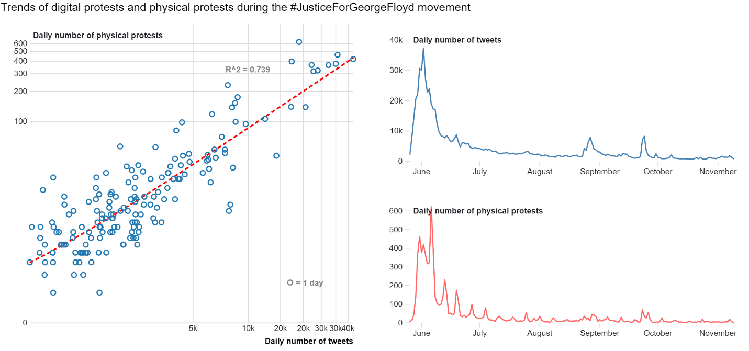

- digital protests (twitter activity related to George Floyd) and physical protests are very closely related in time. On days where people protest more on social media, people also protest more in the street, and vice versa.

- plausible theory: In the case of Justice For George Floyd, people used Twitter to express outrage about events of police brutality and to organize physical protests. During protests, more acts of police brutality were documented and shared on Twitter, which led to yet more protests and to more people showing up to protests, and so on.

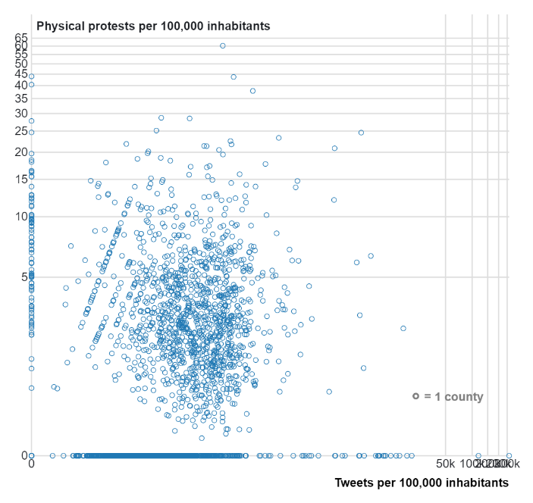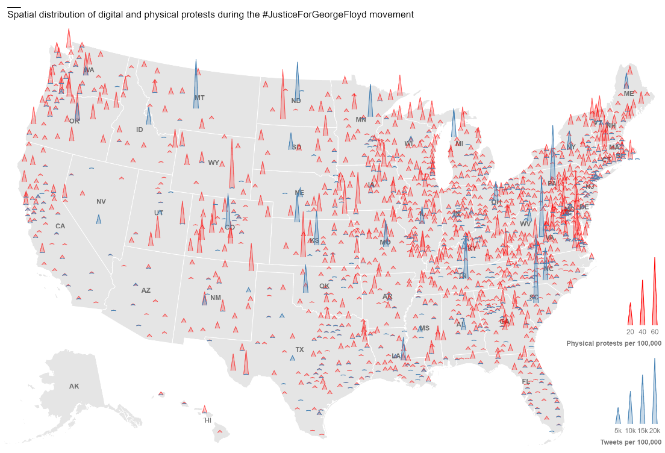

- there is a clear spatial mismatch between the two phenomena: people don't necessarily take to the streets where more digital protests happen. Rather, if on a given day there are more digital protests in one location, it is likely that there will also be more physical protests in another location.

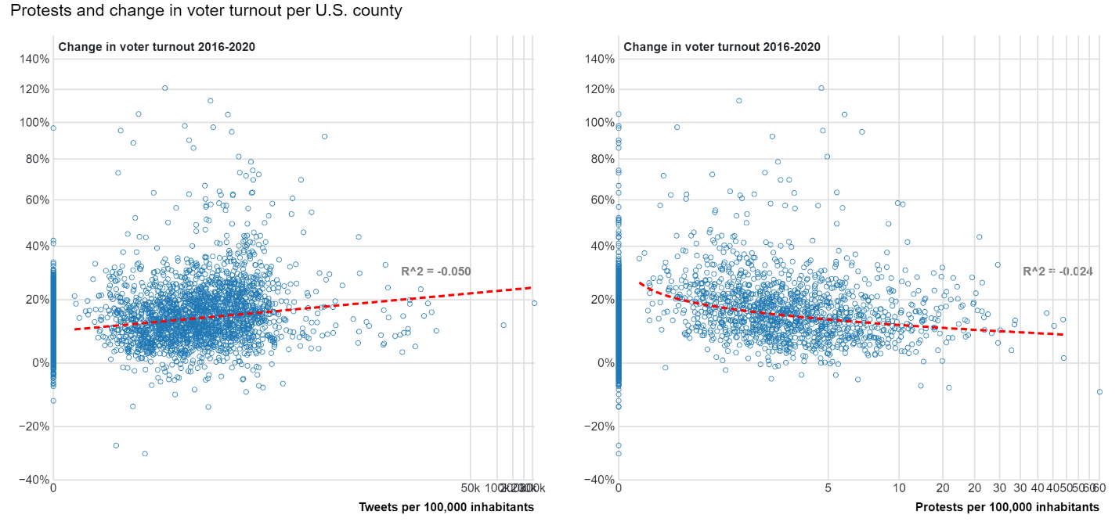

- Although the data is majorly skewed by outliers and the correlations are weak, we can observe a slight positive trend between the number of tweets per 100,000 inhabitants and the change in voter turnout between 2016 and 2020

- Contrary to digital protests, physical protest show a negative correlation with change in voter turnout

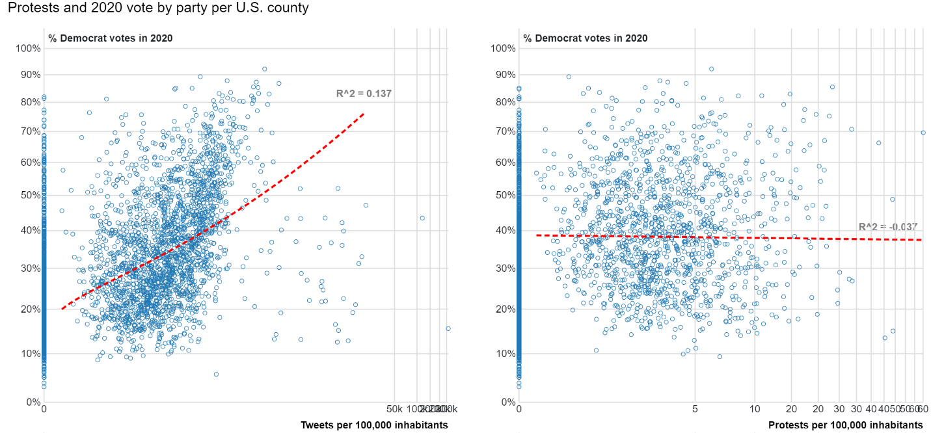

- Again we observe a positive trend between the number of tweets per 100,000 inhabitants and the percentage of democratic votes within a county during the 2020 presidential elections (still, there are many outliers in the data)

- Physical protest, however, bares no trend with democratic votes

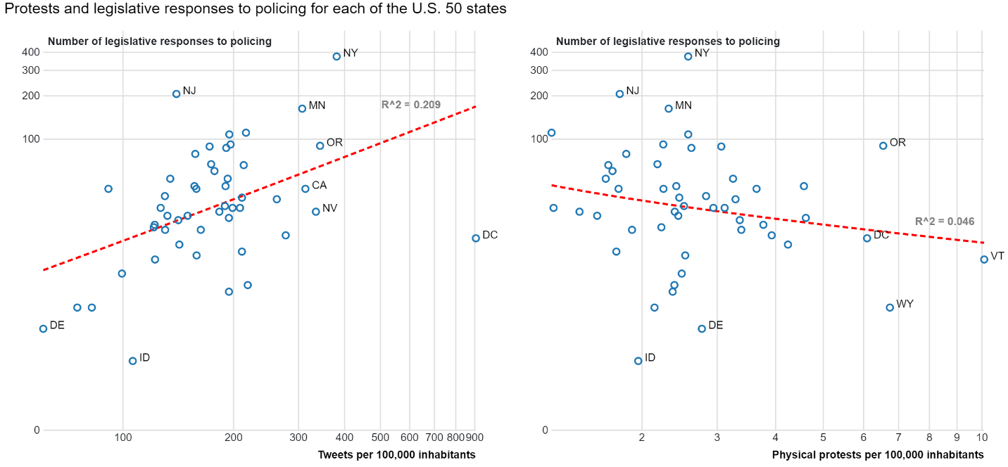

- By aggregating the number digital and physical protests at the state level, I looked at the relationship of each with subsequent state-level legislative responses to policing (from the National Conference for State Legislatures)

- we can observe a positive trend between the number of tweets per 100,000 inhabitants in a given place and the number of legislative responses to policing in that place

- on the other hand, physical protests bear no (or even opposite) relationship with subsequent state-level legislative change

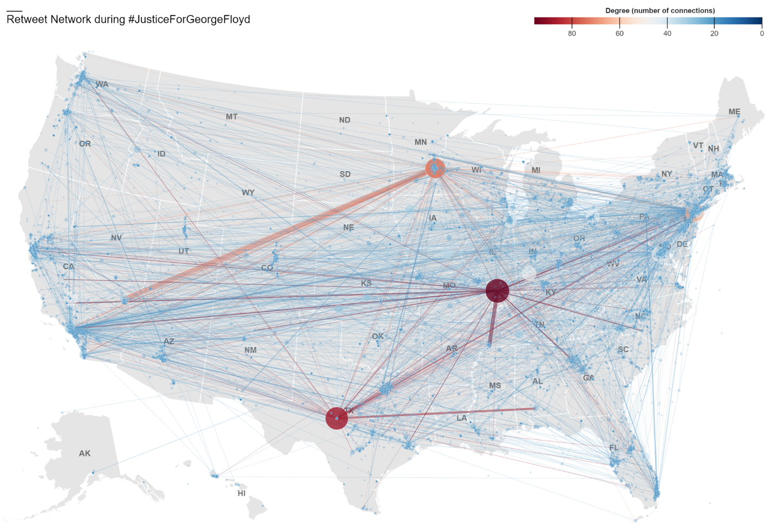

Finally, I mapped the social network from the Justice For George Floyd movement from May to November 2020 in space. In this map:

- Each node/circle represents a user

- Each link represents a connections between two users by means of retweet

- The size and color of a node represents its degree, or the number of users it is connected to

- The thickness of a link represents the strength of the connection between two users, or the number of times a user was retweeted by the same user.

- In order to account for the fact that some users tweeted multiple times from different locations (not frequent but possible), I had to take the take the mean in longitude and latitude coordinates to approximate some of the users’ location. If you have suggestions for a more robust way of dealing with this problem, please let me know.

I have made an interactive visualization of this (<https://observablehq.com/@lnicoletti/tweets-protests>), which has proven very useful to get some initial insight into sources of influence during the case of Justice For George Floyd, in terms of:

- who the most influential users are: some users (e.g. George Floyd’s lawyer Ben Crump, right wing conspiracy theorist Jack Posobiec) were able to reach a wide audience all over the country

- from what geographical locations are these users exercising their influence

- and finally, which geographical locations are these users reaching through their social influence

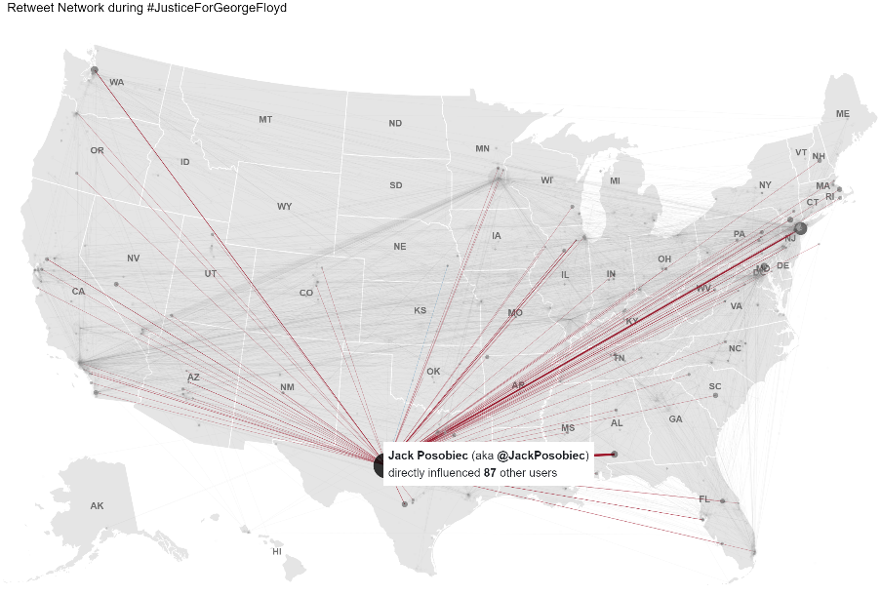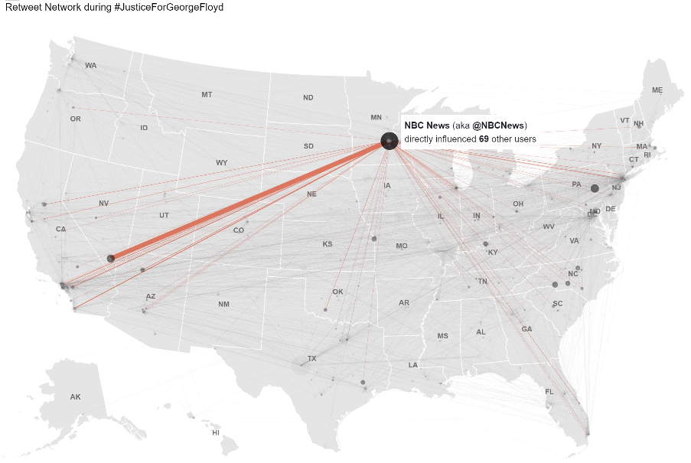

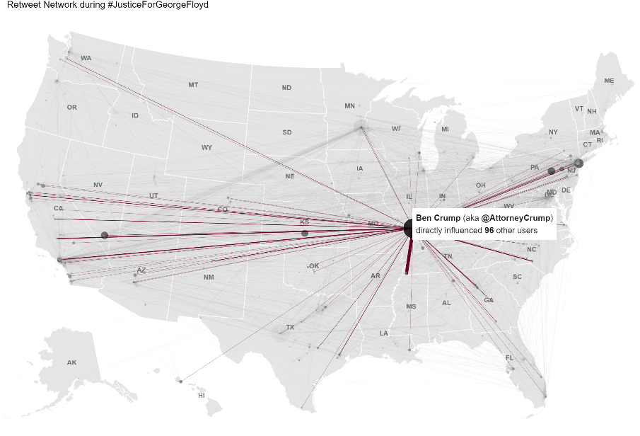

I have run the Louvain community detection algorithm on this network, but I am still trying to make sense of the results:

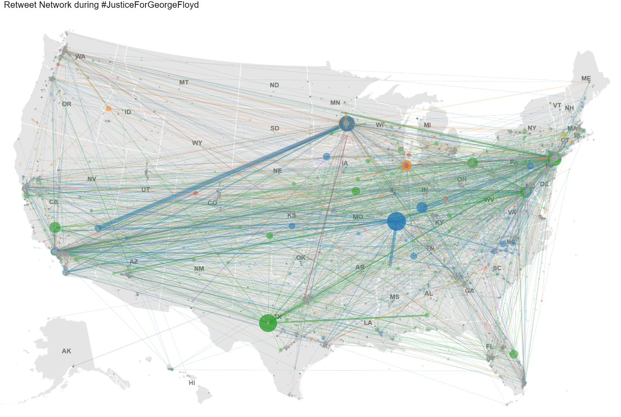This is where I currently am at in my thesis research

I have some ideas of how to move forward:

* Incorporate a temporal element in the network analysis
* Leverage other network characteristics: I don’t have a background in network science, so any suggestions of how to make the network part of this research more interesting would be much appreciated.